**PR 3**

**Swapnil Pande and Logan Nofsinger**

**PANDES and NOFSINLD**

**ME 2160 - 03**

**Project Objectives (1):**

Due​ ​to​ ​the​ ​lack​ ​of​ ​research​ ​of​ ​prosthetic​ ​wrists​ ​compared​ ​to​ ​that​ ​of​ ​terminal​ ​devices,​ ​this proposal​​ ​focuses on the design ​of​ ​a body-powered prosthetic wrist​ capable of pronation and supination of the terminal device.​ ​The​ ​purpose​ ​of​ ​the​ ​prosthetic​ ​wrist​ ​is​ ​to​ ​augment​ ​the​ ​capabilities​ ​of​ ​terminal​ ​devices​ ​that are​ ​already​ ​commercially​ ​available​ ​by​ ​providing​ ​an​ ​additional​ ​degree​ ​of​ ​freedom.​ ​The wrist will be built with a modular design that will interface with a large variety of terminal devices.

**Literature Review (2):**

The human hand alone has 20 degrees of freedom (Wiste, Dalley, Varol, & Goldfarb, 2011). When combined with the additional degrees of freedom of the wrist, elbow, and shoulder, the hand is capable of innumerable different motions while still allowing fine manipulation of objects. A transradial amputation involves cutting the ulna and radius, removing the distal portion of the forearm and the hand. Depending on the location of the cut, the amputation can significantly reduce the amputee’s ability to pronate and supinate the forearm and the force the amputee can apply with the arm.

Designing prostheses to reproduce the function of a human hand poses many difficulties such as size and mass limitations, independent control limitations, strength, and dexterity. As a result, most prosthetic arms have significantly fewer degrees of freedom and increased coupling between joints compared to human hands (Wiste et al., 2011). The three main types of prosthesis include cosmetic, body-powered, and myoelectric, and each type presents various benefits and drawbacks.

The cosmetic prosthesis is the simplest form of prosthesis, providing no actual function. The purpose of the cosmetic prosthetic is simply to replicate the appearance of the original limb to make the amputee more comfortable. Many cosmetic prosthesis are made out of skin-like materials and have similar bone structures to human hands to look realistic. In addition, cosmetic prosthetics generally cost less than five thousand dollars, the lowest price out of the prosthesis types (McGimpsey & Bradford). However, they have minimal functionality and cannot be controlled or actuated. Therefore, cosmetic prosthetics are not viable solutions for accomplishing daily tasks.

Mechanical or body-powered prosthetics are the most common form of functional prosthetics and often cost around $10,000. These prosthetics are commonly controlled using wires attached to a harness on the opposite shoulder. A control cable extends from the harness to the terminal device. The most common terminal device comes in the form of a hook. These hooks are held together with an elastic band and are opened with tension on the control cable from the arm being extended away from the harness (Prosthetic and Orthotic Care, 2017). Body-powered prosthetics can take many other forms, such as passively open claws (U.S. Patent No. US6921419B2).  These simple prosthetics generally have one degree of freedom which limits the position of the user.  Because of this, they are capable of only limited grasp types.

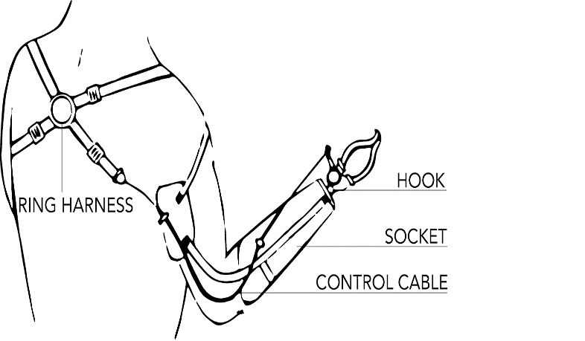            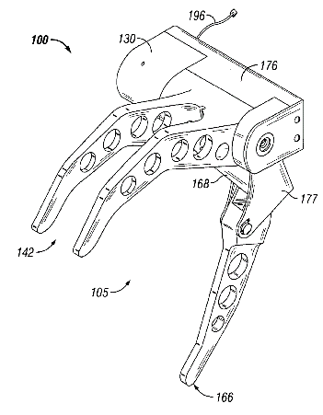

         Figure 1: Examples of Body-Powered Terminal Devices

(Prosthetic and Orthotic Care, 2017), (U.S. Patent No. US6921419B2)

Myoelectric prosthetics are the newest and most expensive form of prosthesis, usually costing between $20,000 and $30,000. These devices sense electrical activity in the muscle of the residual arm and replicate the response that would follow. Depending on the sensor’s accuracy, these hands can be incredibly complex and dexterous with up to 15 degrees of freedom. These intricate myoelectric hands are one of the most active areas in prosthetic research (Cipriani, Controzzi, & Carrozza, 2011), (Dalley, Wiste, Withrow, & Goldfarb, 2009).  These prosthetics allow far more control and flexibility in grasp types than conventional mechanical prosthetics, but they introduce complications with power, energy consumption, speed, and noise. These hands are also known to not provide adequate sensory feedback which for body-powered prosthetics is transferred through the harness (Carey, Highsmith, Maitland, & Dubey, 2008).

The majority of current research and advancements in prosthetics focuses on dexterous terminal devices. However, relatively little has been conducted in designing prosthetic wrists, which have the potential to significantly improve capability for motor tasks (Bajaj, Spiers, & Dollar, 2015). The lack of an articulating wrist has been shown to significantly increase compensatory movements in prostheses patients, such as increased torso bending when turning a doorknob or increased elbow flexion when drinking from a cup (Carey et al., 2008). Advancements in the design of prosthetic wrist have the potential to reduce long-term health issues due to these compensatory behaviors and also provide improved mobility to the terminal device (Bajaj et al., 2015).

The major issues with prosthetic wrist design include increased length and weight due to the complicated nature of the mechanisms involved (Bajaj et al., 2015). The additional weight can significantly increase fatigue due to the prosthetic and reduce its comfort. Increased length poses aesthetic issues and can impact motor coordination because of the difference between the two arms (Bajaj et al., 2015). These problems are especially notable for patients with distal amputations and can increase the rate of abandonment of the prostheses.

Most available prosthetic wrists are passive, holding a fixed position and allowing the user to change that position with the unaffected hand (Bajaj et al., 2015). These wrists are designed with various types of joints such as rotational or ball-and-socket, depending the allowed number of degrees of freedom. While these joints are compact and easy to manufacture, they provide little additional functionality to the amputee.

Active wrists prosthetics use electromechanical actuators to allow for wrist articulation. The most advanced of these prostheses can control both pronation and flexion in the wrist. This is often achieved using motors (Kyberd et al., 2011) or pneumatics (Roose & Plettenburg, n.d.) linked to myoelectric sensors. Few body-powered active wrist prostheses are available and still fewer are capable of pronation. While some available wrist prostheses allow for powered motion and multiple degrees of freedom, they are also heavier and more expensive due to the batteries and actuators.

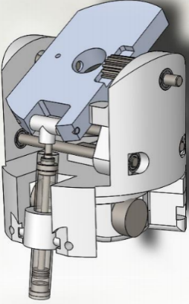       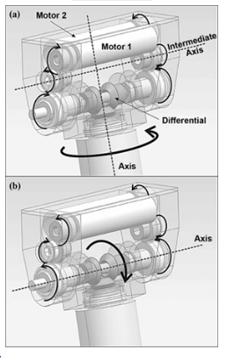

Figure 2: Examples of Body-Powered Wrist Prostheses

(Roose & Plettenburg, n.d.), (Kyberd et al., 2011)

Due to the lack of research of prosthetic wrists compared to that of terminal devices, this proposal will focus on designs of prosthetic wrists to provide the ability to pronate and supinate the terminal device. In addition, the wrist mechanism will have a modular attachment mechanism to allow it to interface with various terminal devices to maximize its utility.

**Design Requirements (3):**

|  |  |
| --- | --- |
| Maximum Length | 4 inches |
| Maximum Diameter | 3 inches |
| Maximum Weight | 400 grams |
| Degrees of Freedom | 1 |
| Minimum Rotation | 160° |
| Minimum Torque | 15 Nm |

The purpose of the prosthetic wrist is to augment the capabilities of terminal devices that are already commercially available by providing an additional degree of freedom. Therefore, the wrist must have a modular design capable of interfacing with many different terminal devices to allow easy interchangeability. It must also be able to bear loads expected in every-day life.

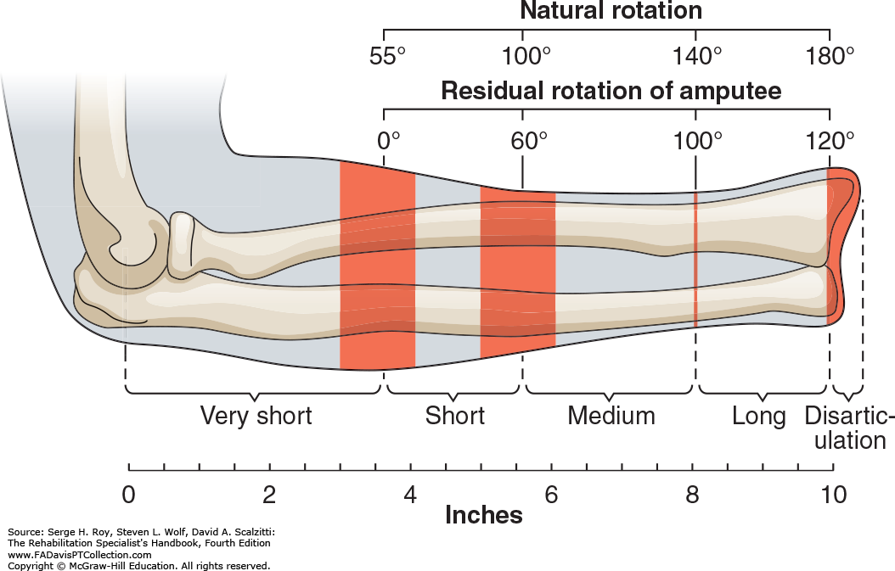

Figure 3: Rotational Range for Amputees with Various Stump Lengths

(Roy, Wolf, & Scalzitti, 2013)

To be compatible with most transradial amputees, the prosthetic should be as short as possible, with a maximum length of 4 inches excluding the link to the terminal device. The prosthetic should also be similar in width to a human wrist and therefore have a diameter of no more than 3 inches.

According to the review of prosthetic wrist mechanisms presented by Bajaj, many wrist rotator prosthetics such the OB Wrist Rotator and MC Electric Rotator weigh around 100 grams (Bajaj et al., 2015). Mechanisms that are lighter are preferred as they reduce the fatigue from usage and allow for more complex terminal devices. However, as this is not a passive wrist and adds functionality to the terminal device, a heavier load of up to 400 gramswould be acceptable.

The prosthetic wrist must be capable of one degree of freedom, allowing for pronation and supination of the hand. Wrist rotation was selected as the required degree of freedom because it provides the greatest increase in maneuverability with a relatively simple and robust joint. The wrist should provide a total range of rotational motion of up to 160 degrees, which is based on the range of motion of a typical human wrist (Boone & Azen, 1979). The neutral position of the wrist should be such that the palm is facing inwards at rest. If the prostheses is body-powered, it must require less than 45 degrees of motion of the controlling joint to minimize the compensatory motion required to actuate the wrist. A typical human hand has a pronation torque of 6-10 N*m (Timm, O'Driscoll, Johnson, & An, n.d.).Therefore, if a factor of safety of 1.5 is used, the prosthetic wrist must be able to exert a torque of 15 N*m.

**Proposed Design (4):**

The proposed wrist prosthetic is capable of pronation and supination and interfaces with terminal devices using a simple press-fit linkage. The prostheses is to be controlled with two Bowden Cables connected across the shoulder joint.

The proposed design uses a rotating collar and friction clutch to convert linear motion in the cables to rotational motion in the shaft. The collar rotates freely about the shaft while the friction clutch may translate but not rotate about the shaft. A four-bar linkage is used as a switch to lock or unlock rotation of the terminal device. In the vertical position a friction plate is held against the shaft to arrest motion while the clutch is held back from the rotating collar. In the horizontal position the friction plate is withdrawn from the shaft and the clutch is pushed to engage the rotating collar, matching the rotation of the shaft to the rotation of the collar.

This design was selected over a biomimetic and an electromechanical wrist prosthetic due to its overall reliability and its low size, mass, and cost.

In the development of this prosthetic, several mechanical changes have been made from the original proposal. The clutch and friction pad of the original proposal were used as a locking and unlocking mechanism. In order to resist a torque of 25 N*m, a force of 6429 lbs would need to be applied to the shaft. This amount of force is unreasonable for the size of the prosthetic wrist and would not allow users to actuate the switch. To circumvent this problem a system of locking gears was introduced, and the proposed four-bar-linkage switch was traded for a sliding actuator which pushes a sliding collar to engage either the pulley or the locking gear.

**Exploded and Unexploded Views (5):**

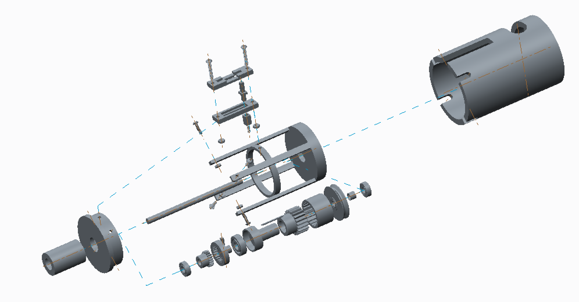

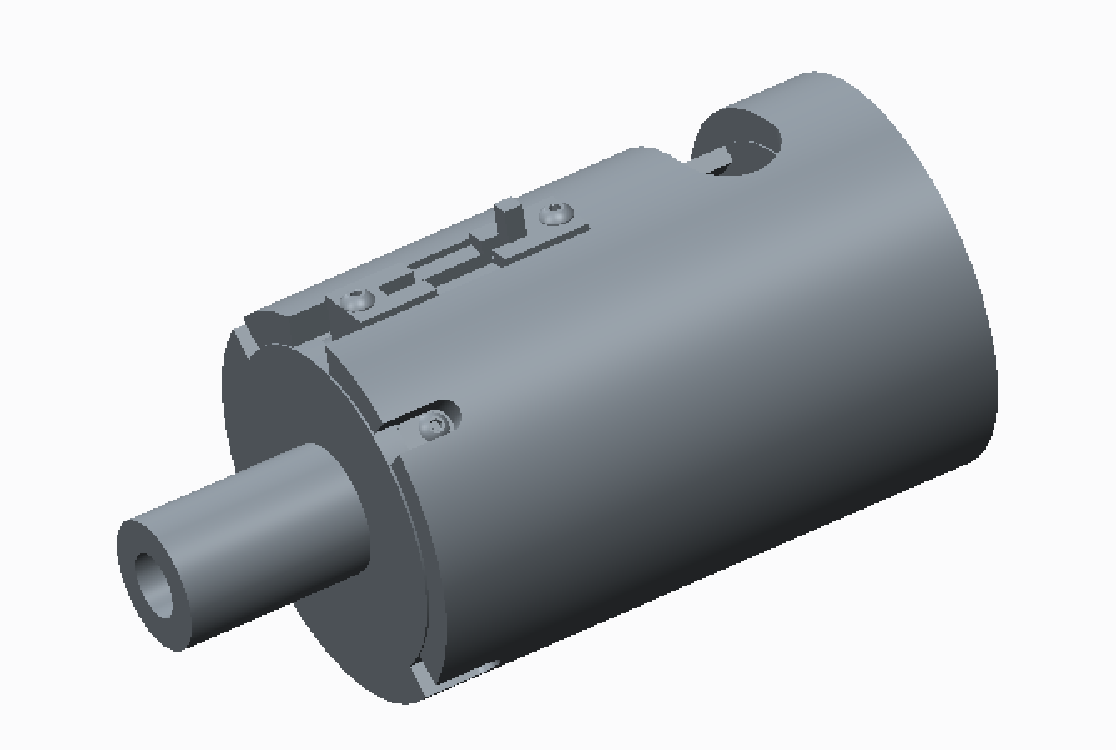

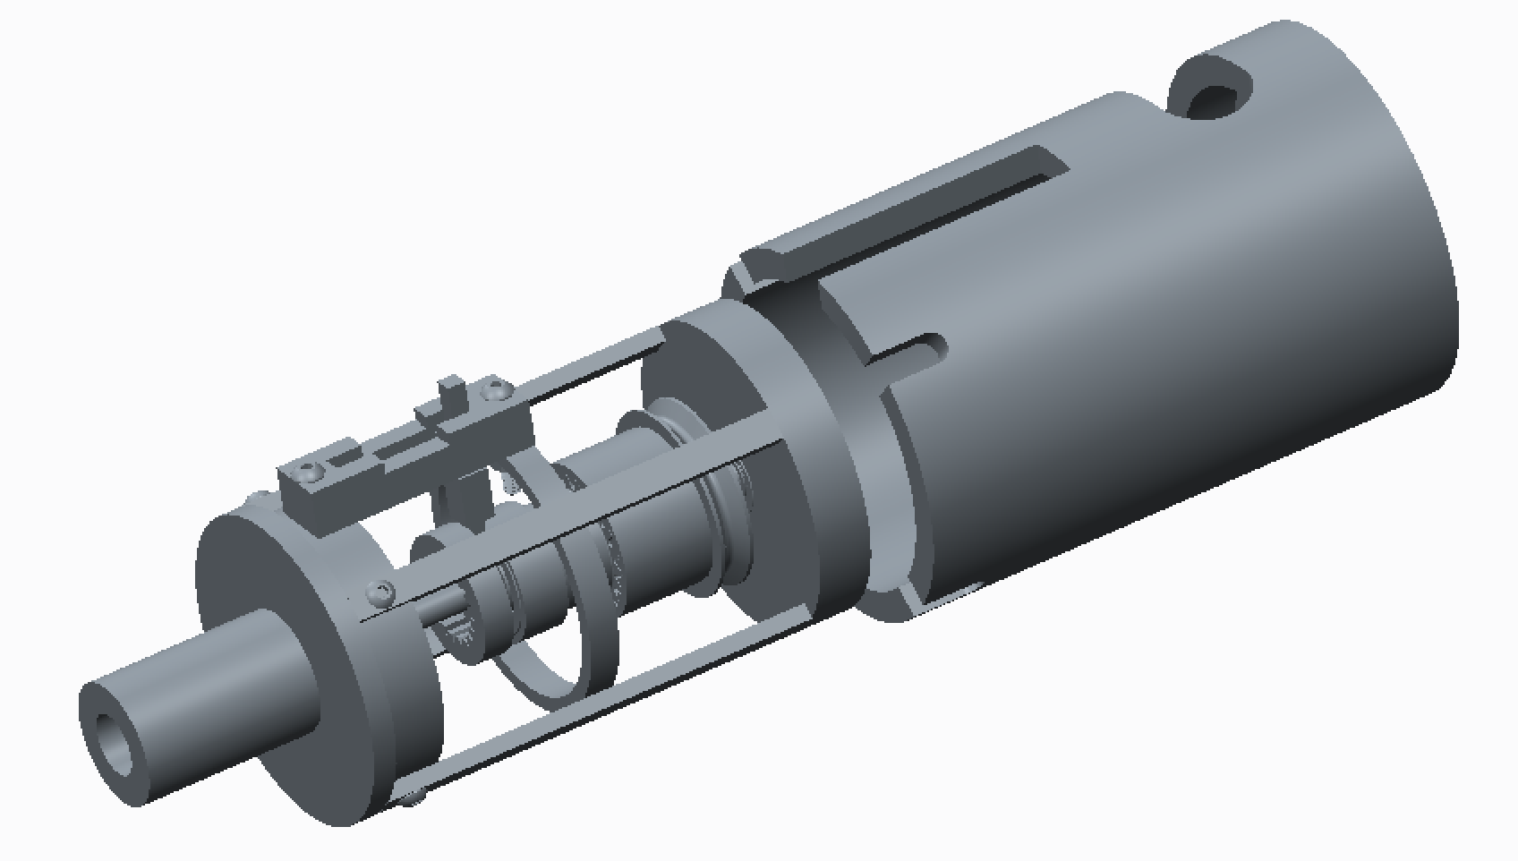

**Design Discussion (6):**

The final model accomplishes the objective of allowing cable-controlled pronation and supination of the terminal device. The device fits within the size constraints (4 inch length excluding terminal device connection and 3 inch diameter) set to ensure that it is compatible with most transradial amputees and is not unnecessarily bulky. The prosthetic is above the desired weight limit, weighing 1.282 lbs581.5 grams; however, standard materials were used to construct this part with an emphasis on cost reduction. The total cost of purchased parts is about $80, which is well under the standard cost of a prosthetic. This cost margin can be used to purchase stronger and lighter materials such as carbon fiber to lower the overall weight of the prosthetic.

This design has many (33) parts, but assembly of these parts is relatively simple. Many connections between parts are press-fit or sliding fits. However, some of these parts, such as the LOCKINGSHAFT and SHAFT_ENGAGER are complicated and difficult to create. The support frame cap and slider box are built to be attached after the internal mechanisms have been put on the shaft. The protective casing can be 3D printed and can be slid on from the back of the assembly and glued in place.

The major area for improvement in this design is the shaft locking mechanism. The current locking mechanism puts a shear load on the slider to hold the shaft in place. In a further iteration of the design, the sliding collar can be symmetric with a shaft engager and gear on each side. These gears can interface with other gears or female gears attached to the pulley and support frame cap to pass shear through the frame instead of the slider.

In designing the prosthetic, we learned that it is important to carefully consider which parts must be grouped together in subassemblies. Constraining parts can take nearly as long, if not longer than creating them, and careful forethought can reduce frustration when constraining complicated subassemblies with multiple sets of constraints.

|  |  |  |  |  |
| --- | --- | --- | --- | --- |
| Quantity | Creo Part Name | Description | Supplier | Cost per Unit |
| 1 | SUPPORT_FRAME | Structural frame of prosthetic | N/A | N/A |
| 1 | SUPPORT_FRAME_CAP | Attaches to end of frame | N/A | N/A |
| 2 | 60355K701_BALL_BEARING | Supports central shaft | McMaster-Carr | $6.25 |
| 1 | KEYED_SHAFT | Central rotating shaft | McMaster-Carr | $11.63 |
| 1 | SLIDER_BASE_TOP | Half of slider support | N/A | N/A |
| 1 | SLIDER_BASE | Half of slider support | N/A | N/A |
| 1 | SLIDER | Sliding switch | N/A | N/A |
| 1 | SLIDER_SPRING | Resets slider positions | McMaster-Carr | $1.68 |
| 1 | SWITCH_CONNECTOR | Connects switch to sliding collar | N/A | N/A |
| 1 | LOCKINGSHAFT | Interfaces with gear to lock shaft | N/A | N/A |
| 1 | 6383K150_BALL_BEARING | Allows rotation in sliding collar | McMaster-Carr | $5.21 |
| 1 | SHAFT_ENGAGER | Uses key to set shaft rotation | N/A | N/A |
| 1 | 5172T120_HT-LOAD_MTL_GEAR—20_D | Connects sliding collar to pulley | McMaster-Carr | $22.10 |
| 1 | KEY | Connects shaft to shaft engager | N/A | N/A |
| 1 | 6381K409_MULTIPURPOSE_  SLEEVE_BR | Spaces pulley from back of frame | McMaster-Carr | $4.33 |
| 1 | 3434T150_PULLEY_FOR_WIRE_  ROPE | Translates cable motion to rotation | McMaster-Carr | $11.07 |
| 1 | PULLEYLOCKER | Connects pulley to gear | N/A | N/A |
| 1 | 6325K950_MTL_GEAR—14-_5__DEG_PR | Locks shaft rotation | McMaster-Carr | $17.49 |
| 1 | HAND_INTERFACE | Connects to terminal device | N/A | N/A |
| 1 | Casing | Protects prosthetic | N/A | N/A |
| 4 | PRT0041 | ¾” screw | McMaster-Carr | $0.14 |
| 4 | PRT0042 | Nut for ¾” screw | McMaster-Carr | $.06 |
| 2 | PRT0043 | ½” screw | McMaster-Carr | $.05 |
| 2 | PRT0044 | Nut for ½” screw | McMaster-Carr | $.03 |

|  |  |
| --- | --- |
| Total Parts | Total Cost of Purchased Parts |
| 33 | $80.72 |

**Technical Drawings (7):**

**Calculations (8):**

(material selection sheet?)

Spring

**Analysis (9):**

Three finite element analyses were conducted for different loading conditions on the prosthetic wrists. The first loading conditions was a moment applied to the end of the shaft with a magnitude of 15 N*m, the maximum **allowable** torque specified in the design requirements. The torque was applied as a coupled force on the radius of the shaft distributed over the portion of the shaft extending beyond the bearing. The displacement of the shaft was constrained at the key. The results are shown in **FIGURE X** below:

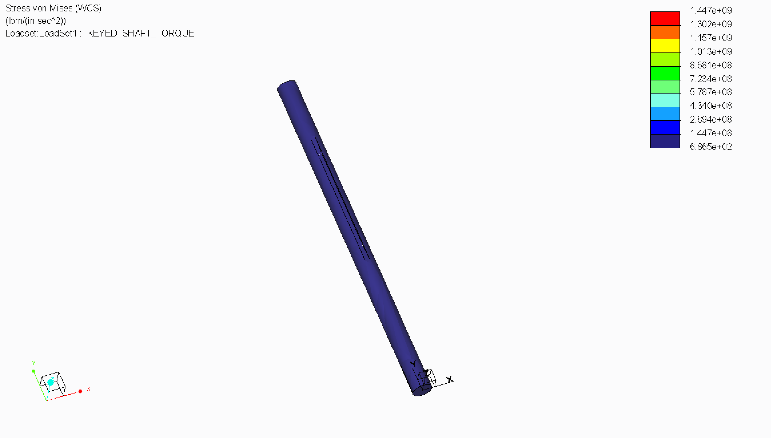

Figure 1: Stress Distribution Result from FEA Analysis for Moment Applied to Shaft

There were stress concentrations at the sharp corners of the key, reaching a maximum of 1118 ksi. This significantly exceed the ultimate tensile strength of 6061 aluminum of 45 ksi, and therefore would result in failure of the part at the key. However, these stress concentrations may be mitigated by rounding the corners of the key and eliminating sharp edges.

The second analysis was a bending analysis of the shaft by applying a load to the portion of the shaft that extends beyond the bearing. The magnitude of the applied force was 200 lbs., according to the design requirements. The displacement of the shaft was constrained at the locations where the bearings support the shaft in the wrist assembly. The results of the analysis are shown below.

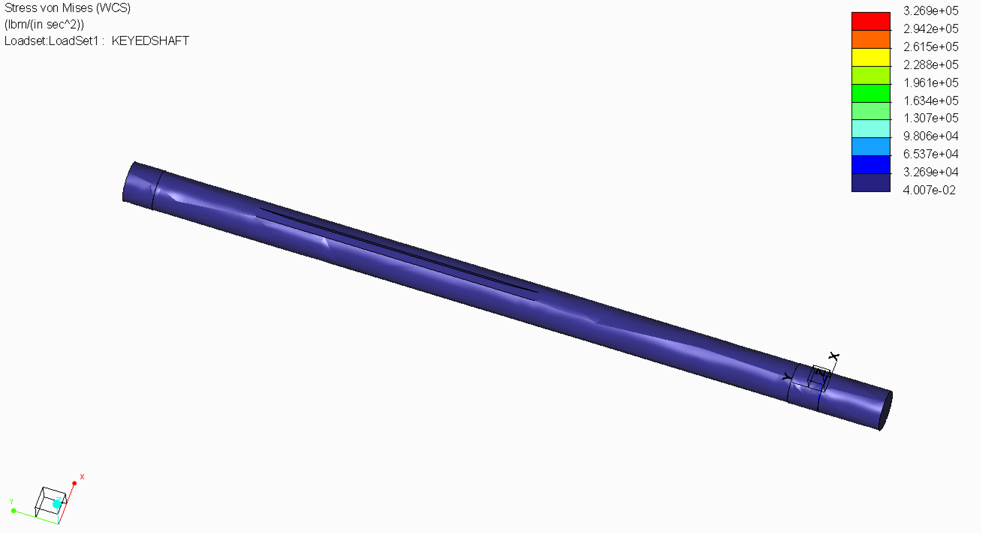

Figure 2: Stress Distribution Result from FEA Analysis for Bending Force Applied to Shaft

Due to the supports from the bearing, the stress on the shaft due to the force was low, not exceeding 84.6 psi anywhere on the shaft. This is below the ultimate tensile strength of 45,000 psi of the 6061 Aluminum meaning that the shaft would not likely not fail due to the bending force.

The final stress analysis involved applying the same bending force to the frame of the prosthetic, which would be supporting the load from the shaft. The 200 lb force was applied to the ends of the four ribs extending towards the front of the prosthetic. The displacement of the frame was fixed on the back surface.

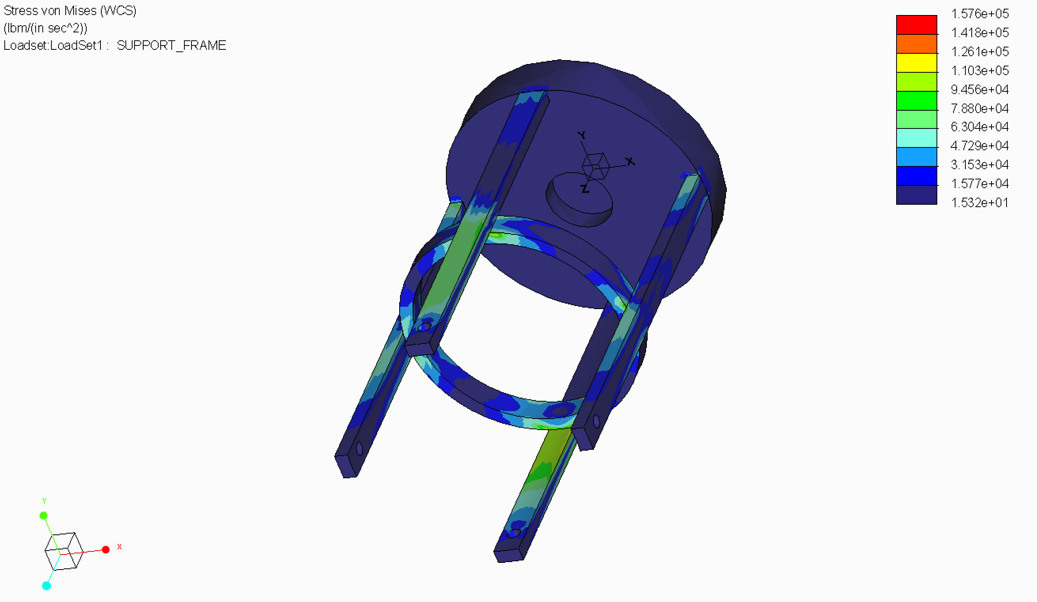

Figure 3: Stress Distribution Result from FEA Analysis for Bending Force Applied to Frame

The maximum stresses occurred at the joint between the hoops and the ribs, reaching a peak value of 408 psi. Since the maximum stress is below the ultimate strength of the 6061 aluminum, the frame would mostly likely not fail under the bending load condition. As mentioned previously, these stress concentrations could be further reduced by rounding the sharp edges, further increasing the strength of the frame.

**Animations (10):**

See animation video submitted electronically.

**Appendix (11):**

**References (12)**

Bajaj, N. M., Spiers, A. J., & Dollar, A. M. (2015). State of the Art in Prosthetic Wrists:

Commercial and Research Devices. *IEEE International Conference on Rehabilitation Robotics (ICORR)*.

Boone, D. C., & Azen, S. P. (1979). Normal Range of Motion of Joints in Male Subjects. *J. Bone*

*Joint Surg. Am.,* *61*, 756-759.

Carey, S. L., Highsmith, J., Maitland, M. E., & Dubey, R. V. (2008). Compensatory movements

of transradial prosthesis users during common tasks. *Clinical Biomechanics,* *23*(9), 1128-1135. doi:10.1016/j.clinbiomech.2008.05.008

Dalley, S. A., Wiste, T. E., Withrow, T. J., & Goldfarb, M. (2009). Design of a Multifunctional

Anthropomorphic Prosthetic Hand With Extrinsic Actuation. *IEEE/ASME Transactions on Mechatronics,* *146*, 699-706. doi:10.1109/TMECH.2009.2033113

Kyberd, P. J., Lemaire, E. D., Scheme, E., MacPhail, C., Goudreau, L., Bush, G., & Brookshaw,

M. (2011). Two-degree-of-freedom powered prosthetic wrist. *Rehabilitation Research & Development,* *48*(6), 609-618.

McGimpsey, G., & Bradford, T. C. (n.d.). Limb Prosthetics Services and Devices. Worcester,

Massachusetts.

Prosthetic and Orthotic Care. (2017). Types of Upper Extremity Prostheses. Retrieved October

10, 2017, from http://www.pandocare.com/upper-extremity-types/

Roose, C., & Plettenburg, D. H. (2014). *Two-degree-of-freedom pneumatically powered wrist*

*prosthesis* (Unpublished master's thesis). Delft University of Technology.

Roy, S. H., Wolf, S. L., & Scalzitti, D. A. (2013). *The rehabilitation specialist's handbook* (4th

ed.). Philadelphia, PA: F.A. Davis.

*U.S. Patent No. US6921419B2*. (n.d.). Washington, DC: U.S. Patent and Trademark Office.

Cipriani, C., Controzzi, M., & Carrozza, M. C. (2011). The SmartHand Transradial Prosthesis.

*Journal of NeuroEngineering and Rehabilitation,* *8*(29). doi:10.118610.1186/1743-0003-8-29

Wiste, T. E., Dalley, S. A., Varol, H. A., & Goldfarb, M. (2011). Design of a Multigrasp

Transradial Prosthesis. *ASME. J. Med. Devices,* *5*(3). doi:10.1115/1.4004653